**Class Project Phase III**

**CSE 360 - Fall 2022**

Team Number: 47

Team Members:

Jason Roberts

James Weber

Garret Goodwin

Ryan Radtke

Johnny Duong

1. Upload your complete code as a zip file to the google drive of your team leader or one of your team members and provide a link to the google drive code (make sure to give permission so that anyone has the link can download the code)

Google drive link here:

<https://drive.google.com/file/d/1JMmRGD4pjxPrsZc_ppjRuAUWvbLGbx-9/view?usp=sharing>

1. Link for a video demo (up to 5 minutes) demonstrating working functionality of the software (you can record this as a YouTube video or upload your video to the google drive of your team leader or one of your team members and provide a link to the google drive video

YouTube Link:

<https://youtu.be/c1F90g7lghk>

1. Screenshot of your GitHub repository showing commits made by each member of the team. If you have used any other repository like bitbucket, screenshot of that repositor is acceptable.

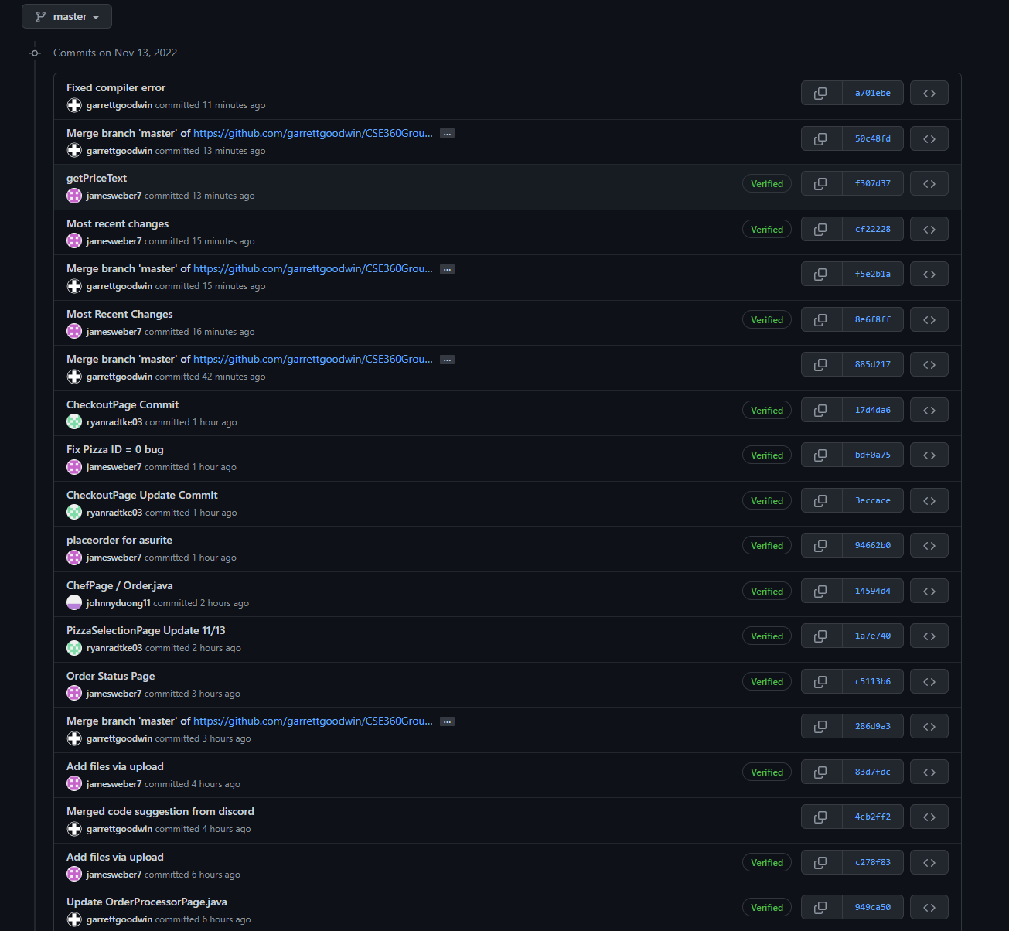

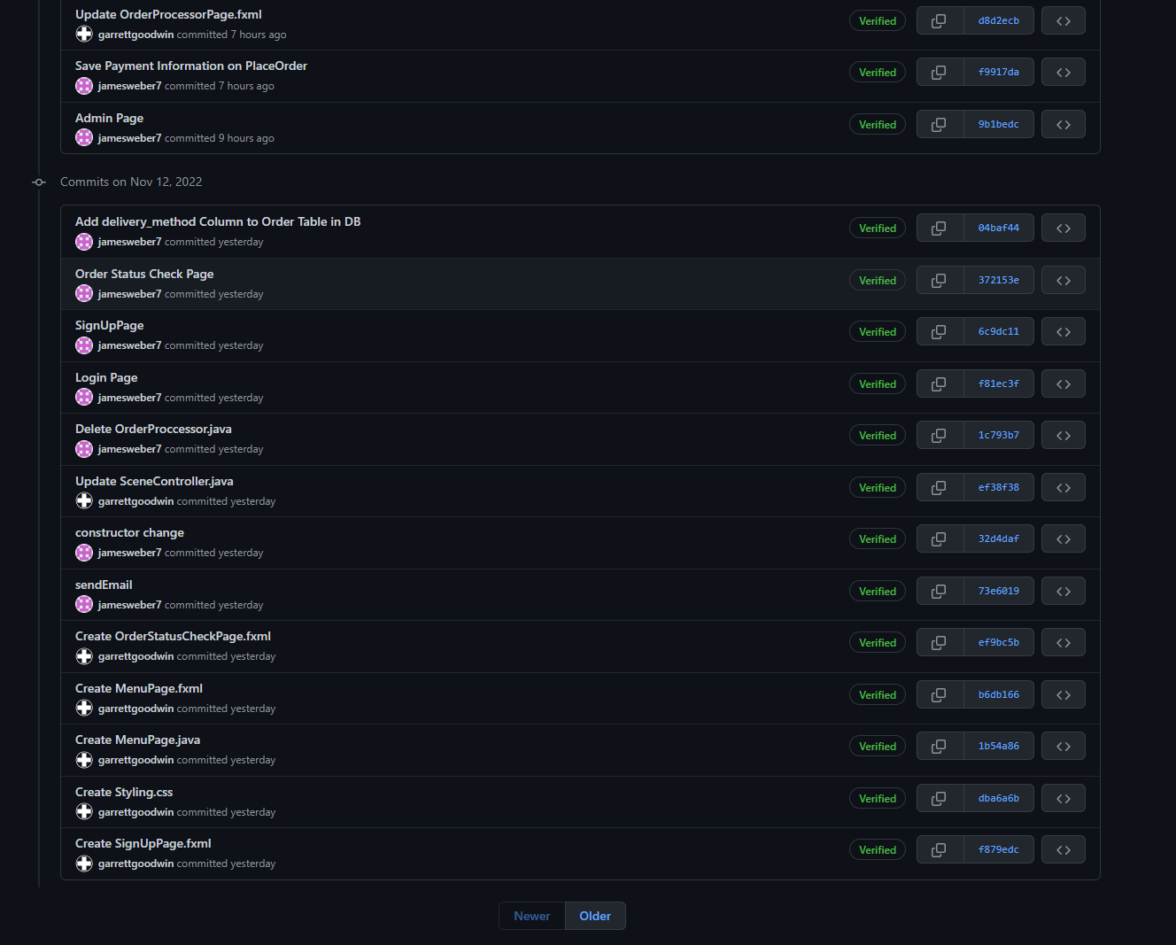

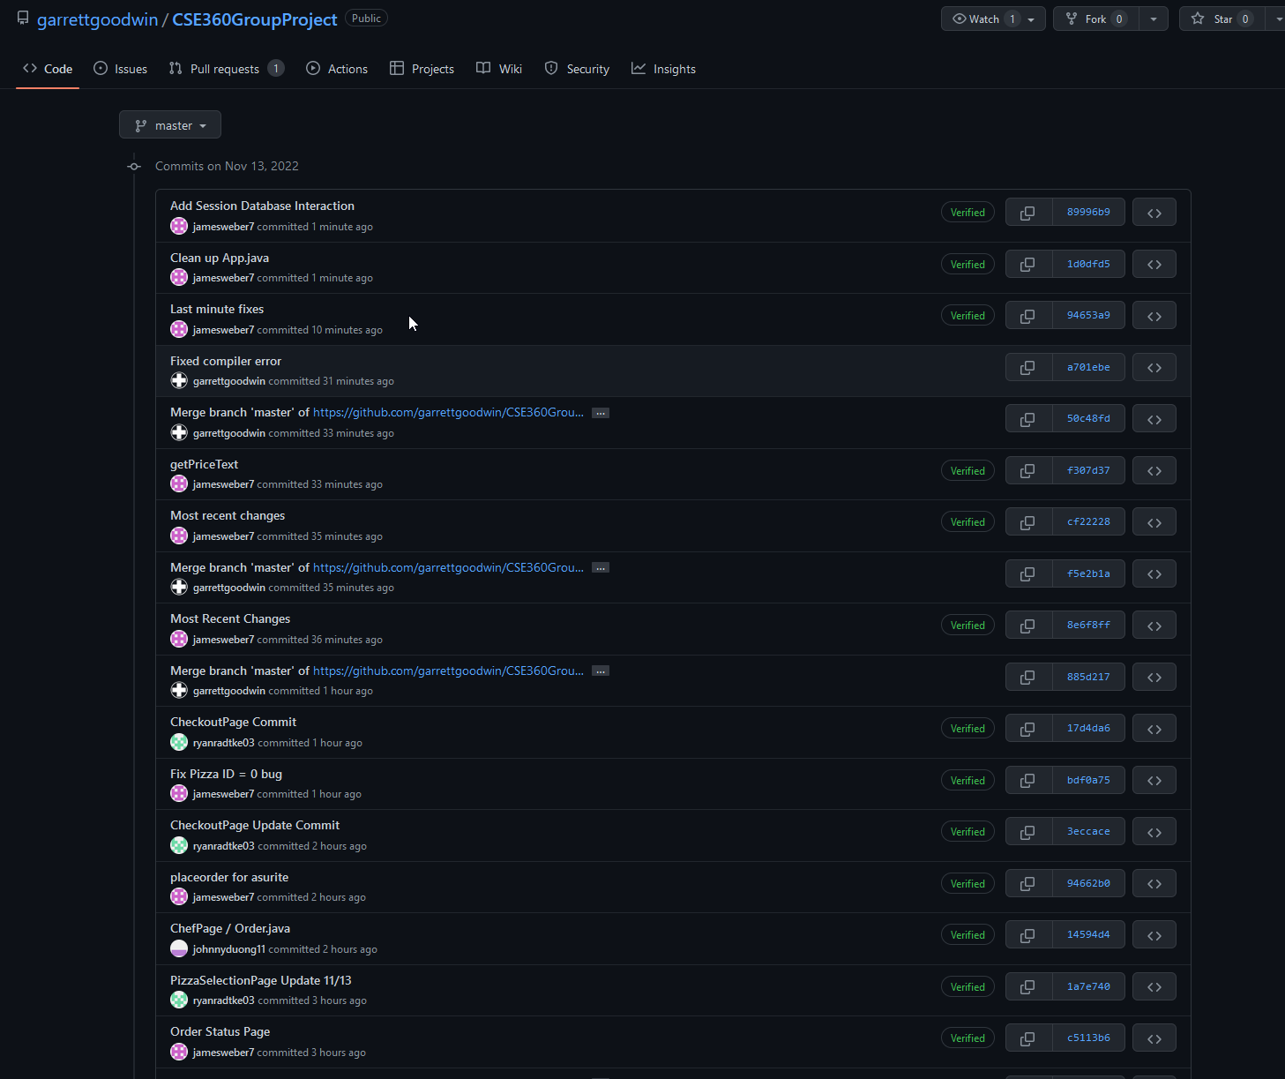

1. Screenshot of your teams’ Jira schedule

